Unit 7 It’s raining.
Ⅰ.你知道吗？
请看下面的图，你知道怎么用英文表达天气吗？
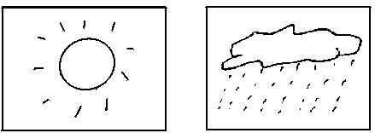
1. 2.
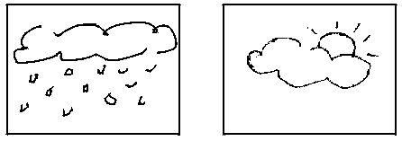
3. 4.
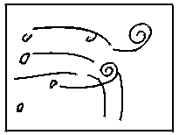
5.
Ⅱ.看图写出他们在做什么？
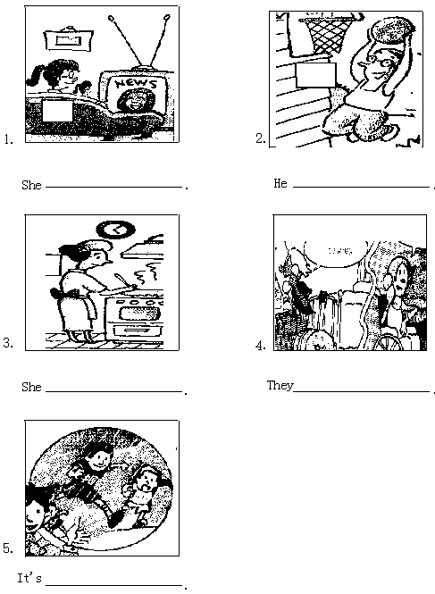
Ⅲ.完成对话
A:Hello!This is Alice.
B:Hi,Alice.This is Bob.How’s it ?
A:Not .How’s the there?
B:It’s windy.What are you now?
A:It’s raining.I am TV at home.

附参考答案：
Ⅰ.1.sunny 2.rainy 3.snowy 4.cloudy 5.windy
Ⅱ.1.is watching TV
2.is playing basketball
3.is cooking
4.are making a telephone call/are telephoning
5.raining
Ⅲ.going,bad,weather,doing,watching

